Name ______________________________ Date ________________
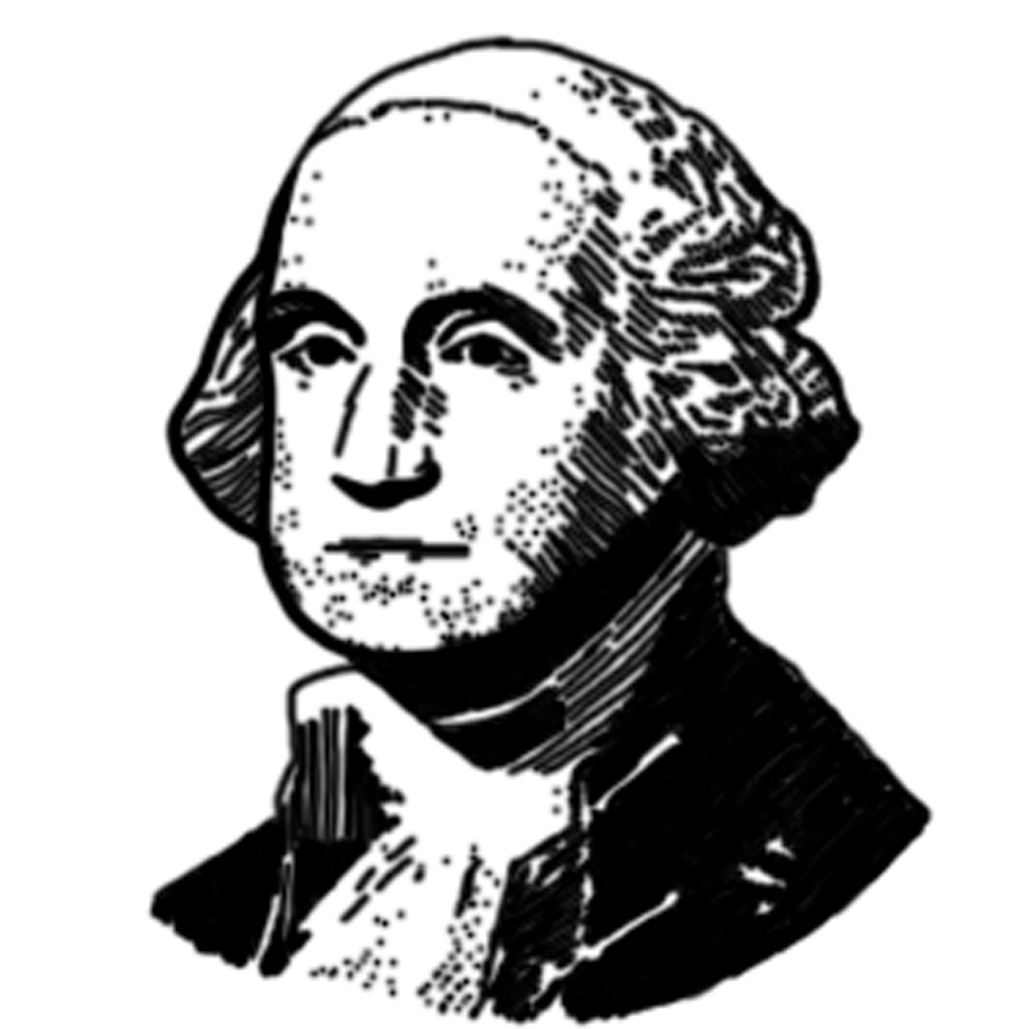
President's Day

Fact or Opinion

Directions: Write F on the blank in front of the sentences that are
facts.
Write O on the blank in front of the sentences that are
opinions.

____ 1. George Washington was a wise and courageous man admired for his honesty.

____ 2. George Washington was born on February 22, 1732.

____ 3. Abraham Lincoln was our 16th President of the United States of America.

____ 4. Abraham Lincoln was a great leader.

____ 5. Abraham Lincoln was nicknamed "Honest Abe."

____ 6. George Washington was the first President of the United States of America.

____ 7. Abraham Lincoln was a good looking man.
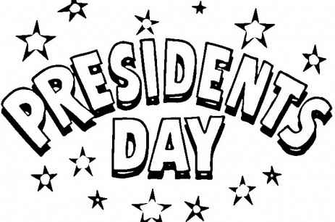
____ 8. Ronald Reagan was born on February 6, 1911.

____ 9. President's Day is the best national holiday.

____ 10. George Washington was very brave.

____ 11. President's Day is celebrated on the third Monday of February.

____ 12. Presidents that were born in February are wonderful.

____ 13. On February 22nd of almost every year since 1888, Washington's Farewell
Address has been read in the US Senate.

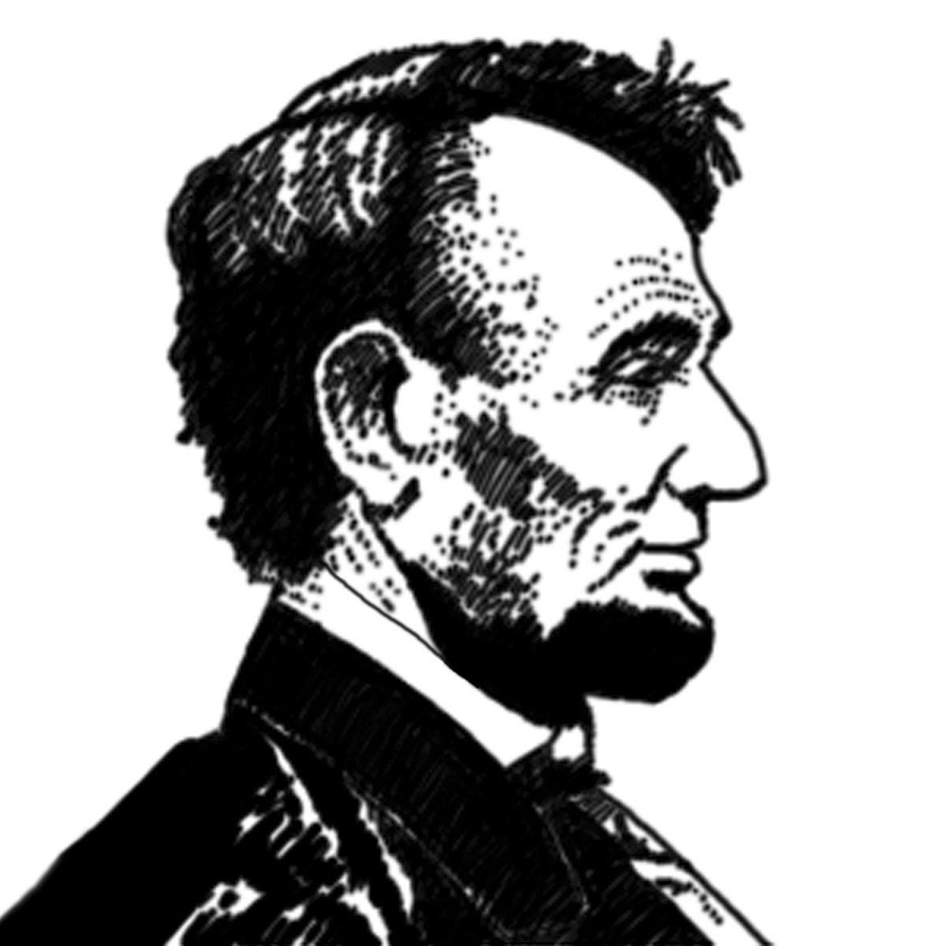
____ 14. Abraham Lincoln was born in Hardin County, Kentucky.

____ 15. We should always celebrate President’s Day.

